How to get the SSL Certificate

- Start Menu Type MMC
- Microsoft Management Console Window will open
- File Add/Remove Snap-in Console Root Certificates Current User Select your name
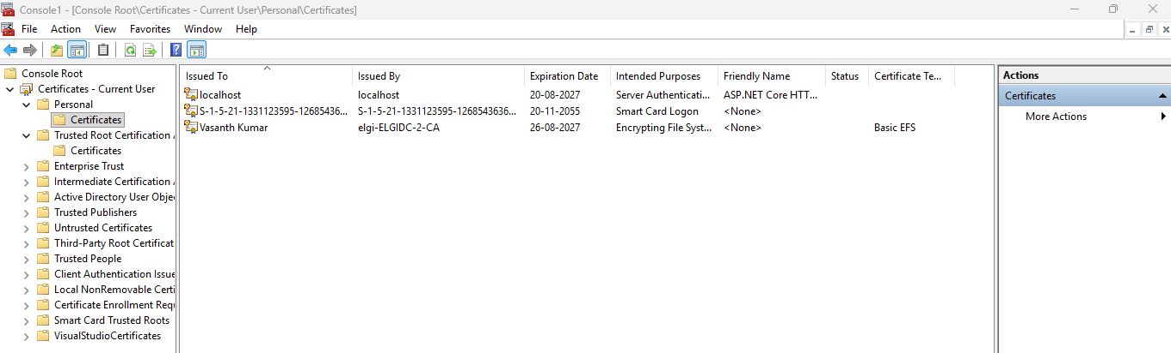

if your organization uses a corporate CA certificate, get the company's root CA .cer/.pem certificate

ChatGPT said:
Yes. If you're on a corporate network, the SELF_SIGNED_CERT_IN_CHAIN error may be caused by your company's HTTPS proxy/security software. You need to get the corporate root CA certificate and tell Node.js to trust it.

1. First check whether you actually need a corporate CA
Run:
npm config get proxy
npm config get https-proxy
Also:
echo %HTTP_PROXY%
echo %HTTPS_PROXY%
If these show a corporate proxy URL, that's a strong indication.
If they are all null/empty, your company may still be doing HTTPS inspection transparently.

2. Get the corporate CA certificate
There are two common ways.

Option A — Ask your IT team
Ask them for:
"The corporate root CA certificate used for SSL/TLS inspection, preferably in PEM or Base-64 encoded X.509 .cer format, for Node.js/npm."
You may receive something like:
CorporateRootCA.cer
or:
CorporateRootCA.pem
Do not use a random certificate downloaded from the internet. It needs to be the CA your organization actually uses.

3. You can also check Windows' trusted certificates
Press:
Win + R
Enter:
certmgr.msc
Then go to:
Trusted Root Certification Authorities
└── Certificates
Look for certificates belonging to your organization's security/proxy infrastructure.
Common enterprise products may have certificates associated with things such as:
  - Zscaler
  - Fortinet
  - Palo Alto
  - Cisco
  - Symantec
  - Netskope
  - Blue Coat
Don't assume a certificate is the correct one merely because it has one of these names. Your IT/security team should confirm which certificate is used for HTTPS inspection.

4. Export the certificate
If IT identifies the correct certificate:
Open certmgr.msc.
Go to Trusted Root Certification Authorities → Certificates.
Find the corporate CA.
Right-click → All Tasks → Export.
Choose Base-64 encoded X.509 (.CER) if available.
Save it somewhere, for example:
C:\certs\CorporateRootCA.cer

5. Tell Node.js to trust it
You can configure Node using NODE_EXTRA_CA_CERTS.
For example:
setx NODE_EXTRA_CA_CERTS "C:\certs\CorporateRootCA.cer"
You should see a message indicating that the value was saved.
Close the Command Prompt and open a new one afterward because setx affects future processes.
Check:
echo %NODE_EXTRA_CA_CERTS%
You should see:
C:\certs\CorporateRootCA.cer

6. Test npm
Now try:
npm view azure-functions-core-tools version
If the certificate was the problem, npm should now be able to communicate with the registry/download infrastructure without:
SELF_SIGNED_CERT_IN_CHAIN
Then you can try:
npm install -g azure-functions-core-tools@4

Important: don't do this
You may see advice to fix the problem with:
npm config set strict-ssl false
or:
npm config set strict-ssl false
npm install ...
I wouldn't recommend this as the permanent solution.
It effectively tells npm:
"Don't verify that the server's certificate is trustworthy."
The better solution is:
Corporate CA
↓
Install/export trusted CA
↓
NODE_EXTRA_CA_CERTS
↓
Node.js trusts corporate HTTPS inspection
↓
npm works normally

If you want, we can identify the certificate together
Run this command:
npm config get https-proxy
and:
npm config get proxy
Paste the results here. Don't paste passwords, tokens, usernames, or complete proxy credentials if they appear in the output. I can then tell you whether this looks like a corporate-proxy certificate issue and what to do next.

